| **Section 1 – Practice Assessment Task Overview and Description** |
| --- |

# Case Study

A Client has requested you to design a website for them.

This website is for a personal portfolio / resume, showing the World Wide Web what work that they have done in the past, and previous education. They have mocked up a design in Adobe XD and attached it below:

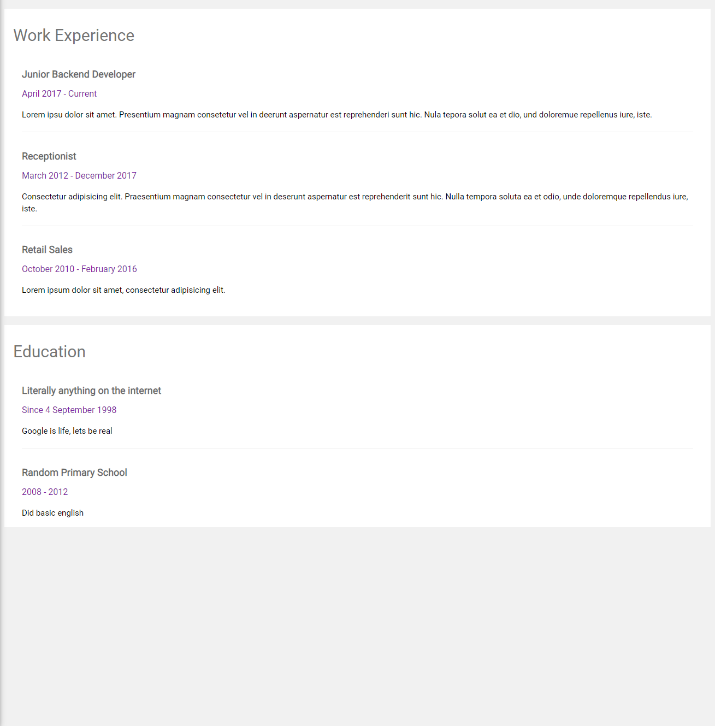

# Tasks

1. Setup your development environment by installing ‘Github Desktop’ and VS Code Live Server.
2. Create a new Github repository called ‘*WebProg_Prac_Chalange*’.

Click or tap here to enter text.

1. Clone the newly created GitHub Repository with Github Desktop and open in VS Code
2. Build the website using HTML and CSS, trying to replicate the design as closely as possible.

| **Section 2 – Practice Assessment Task Submission Information** | |
| --- | --- |
| **Submission Details** | **Due date:** |
| Do your best at completing this assessment in your own time. You may submit it on canvas for feedback, but as this is just a practice it will not count to your final competency. |

| **Summary of Evidence to be Submitted** |
| --- |
| * GitHub repository created and linked in this submission |
| * The final website developed as an image (png, jpg, gif) |
|  |
|  |
|  |
| The task will be assessed as satisfactory when all of the required evidence listed has been satisfactorily demonstrated.  * If applicable, for graded units, the task must be satisfactorily completed before marks will be allocated. Refer to your unit outline for more information. |

| Section 3 – Assessment Task Criteria and Outcome | |
| --- | --- |
| *All items/criteria must be demonstrated satisfactorily to achieve this task. The items/criteria for this activity will be assessed as S – Satisfactory or US – Unsatisfactory.* | |
| Items/criteria | |
| 1. | Demonstrated HTML and CSS skills |
| 2. | Provided |
| 3. |  |
| 4. |  |

|  |  |
| --- | --- |
| **Section 4 – General Assessment Information** | |
| **Decision Making Rules** | Each activity in the assessment task must be satisfactorily completed for the task to be assessed as satisfactory.  Every task must be satisfactorily completed to be assessed as competent in the unit.  *\* For graded units, competence must be demonstrated before a mark can be given.* |
| **Plagiarism** | There are serious penalties for plagiarism that may include repeating a new assessment task or being withdrawn for the unit / course.  Students must ensure that all assessments are their own work (or group work and clearly noted as such).  Please refer to [www.swinburne.edu.au/corporate/registrar/plagiarism/index.html](http://www.swinburne.edu.au/corporate/registrar/plagiarism/index.html) |
| **Reasonable Adjustment** | Students may request reasonable adjustment for assessment tasks.  Reasonable adjustment usually involves varying:   * the processes for conducting the assessment (eg: allowing additional time, varying the venue) * the evidence gathering techniques (eg: oral rather than written questioning, use of a scribe, modifications to equipment)   However, the evidence collected must allow the student to demonstrate all requirements of the unit.  If you have any other issue that may impact your ability to undertake the assessment, please discuss with your teacher. |
| **Re-submission** *(where tasks are not satisfactorily completed)* | Assessment tasks that are not satisfactory can be resubmitted up until the end of the unit as scheduled on the Unit Outline. The timing on this may depend on the equipment required for this assessment task.  Resubmissions received after the scheduled unit end date may not be accepted unless approved by the teacher prior to the end date.  Note: Assessment tasks submitted for the first time after the unit end date as scheduled in the Unit Outline will not be assessed and the student should re-enrol into the unit. |
| **Special consideration** | Students may apply for Special Consideration where personal circumstances have adversely affected their task result or ability to undertake an assessment. A Special Consideration form can be completed prior to, but no later than 3 days after, the date of assessment and submitted to the relevant Manager. |
| **Work Health & Safety** | Activities may require the use of equipment or participation in group exercises. If the teacher identifies any unsafe activity or potentially dangerous situations, the teacher can stop the assessment at any time. |